

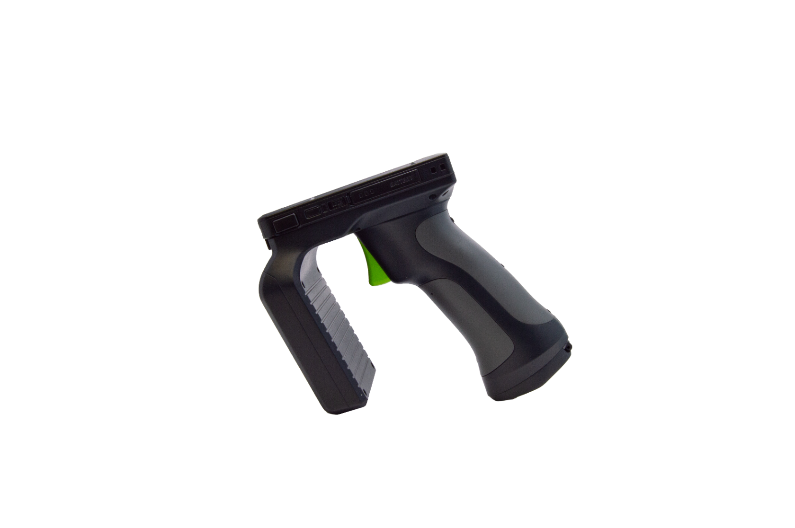

116 Village Blvd, Suite 305, Princeton, NJ 08540 USA

T: + 1-609-256-4700 F: +1-609-228-4373

info@koamtac.com [www.koamtac.com](http://www.koamtac.com)

KDC480/485 UHF

Quick Guide

­

**Contents**

1. Product Introduction 2

1.1 KDC480/485 1.0W UHF Reader Diagram 2

1.2 KDC480/485 0.5W UHF Reader Diagram 3

1.3 How to turn on and off 3

2. Bluetooth Pairing 4

2.1 Bluetooth Profiles Explained 4

2.2 Pairing a KDC480/485 to your smart device 4

2.3 Bluetooth Pairing a KDC480-BLE/485-BLE to your smart device with special barcodes 5

3. Usage 7

3.1 Read RFID tag and Barcode with trigger: Trigger mode 7

3.2 Toggling the Read Mode: Barcode mode vs. UHF mode 7

3.3 Changing the UHF Read Tag Modes: Single, Multiple, or Active 8

3.4 UHF Tag Counting (Beep Count) 9

3.5 Phone Charging Option 10

3.6 Using Keyboard Wedge (HID Keyboard) 10

3.7 Using KTSync – Android/iOS 10

3.8 Using KTSync Keyboard – Android 11

3.9 Using KTSync Keyboard – iOS 12

3.10 Using “KDCUHF” Application – Android/iOS 13

3.11 Using other Developed Applications with free SDK – Android/iOS 15

4. Product Specifications 16

4.1 1.0W UHF Reader 16

4.2 0.5W UHF Reader 16

# Product Introduction

The 1.0W and .05W UHF Readers attach to the back of KDC480/485 SmartSled Scanners.

The 1.0W or 0.5W UHF Reader is attached to the back of KDC480/485 SmartSled Scanners.

## KDC480/485 1.0W UHF Reader Diagram

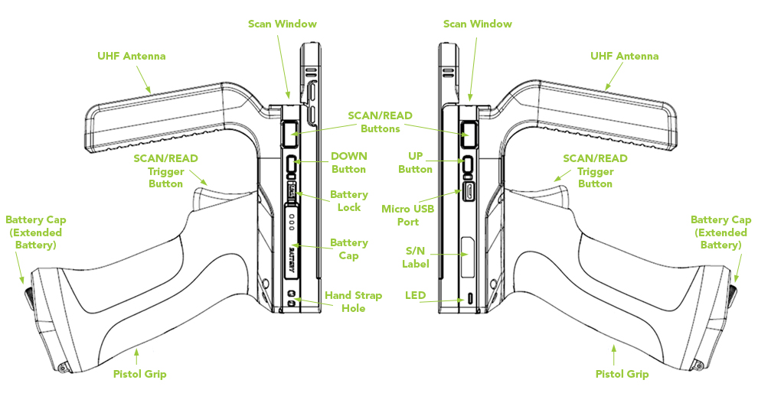

*\* 1.0W UHF Reader mounted to KDC480*

## KDC480/485 0.5W UHF Reader Diagram

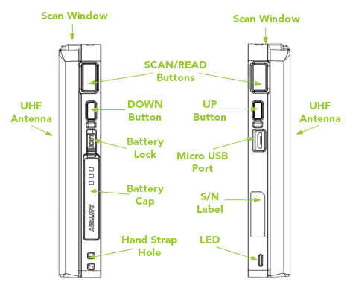

*\* 0.5W UHF Reader mounted to KDC480*

## How to turn on and off

Refer to the figure in section 1.1 or 1.2 to locate the SCAN and DOWN buttons.

1. Press SCAN and DOWN buttons simultaneously for 3 seconds.
2. The KDC will beep when it is turned ON.

*\* 2017/2018/early 2019 versions of KDC480 turn on upon pressing scan button.*

# Bluetooth Pairing

Connecting your KDC using Bluetooth is made easy with the below pairing barcodes. If you are unsure which profile is right for you, please visit [www.koamtac.com](http://www.koamtac.com) for more information.

## Bluetooth Profiles Explained

1. **HID Profile**: Allows one-way Bluetooth communication with an Android or iOS host device. The KDC only transmits data to the host device.
2. **SPP Profile**: Allows two-way Bluetooth communication. The KDC transmits data to the host device and the host device can transmit data back to the KDC.
3. **HID Windows Profile**: Allows one-way Bluetooth communication with Windows host device. The KDC only transmits data to the host device.

**Note:** HID inputs data directly into an application. SPP requires the KOAMTAC SDK to input data into an application. To gain access to the SDK, please complete the form here: <https://www.koamtac.com/sdk/>

## Pairing a KDC480/485 to your smart device

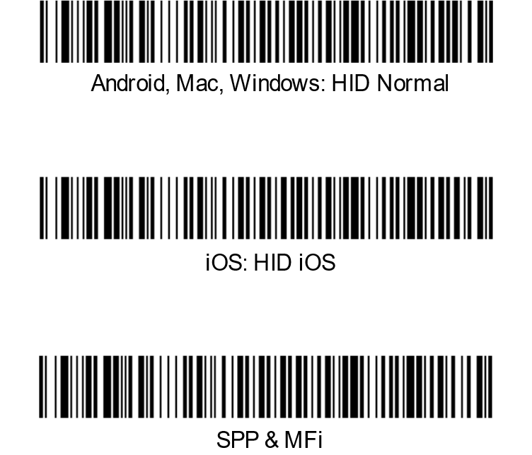

1. Navigate to the Bluetooth setting on the host PC, Mac, Smartphone, or Tablet.

2. Ensure that Bluetooth is enabled on the host device and searching for devices.

3. Using the KDC, scan the pairing barcode that corresponds to your desired Bluetooth profile. If you are unsure which Bluetooth profile is right for you, please refer to the previous panel.

4. Check the list of available Bluetooth devices on your host device.

5. From the list, select KDC480/485 listed by serial number in brackets that matches the serial number found on the back side of the KDC480/485.

6. In HID mode, KDC480/485 is now ready to use.

7. To complete connection in SPP/MFi mode, launch KTSync or your application and select KDC480/485.

* The KDC480/485 will beep when successfully connected.

## Bluetooth Pairing a KDC480-BLE/485-BLE to your smart device with special barcodes

|  |
| --- |
| Bluetooth Profile & Pairing |
| #1. HID-BLE & Pairing (Android, iOS, Mac) |
|  |
| #2. HID-Windows & Pairing (Windows) |
|  |
| #3. SPP-BLE & Pairing (Android, iOS, Mac, Windows) |
|  |

1. Navigate to the Bluetooth setting on the host device and ensure that Bluetooth is both enabled and searching for devices.
2. Using the KDC, scan the pairing barcode above that corresponds to your desired Bluetooth profile. If you are unsure which Bluetooth profile is right for you, please refer to Chapter section 2.1.
   * If you use an Android, iOS, or Mac device and desire an HID connection, then scan barcode #1 above.
   * If you use a Windows device and desire an HID connection, then scan barcode #2 above.
   * If you desire an SPP connection for any device, then scan barcode #3 above.
3. In HID or HID Windows Profile, check the list of available Bluetooth devices on your host device. From the list, select the KDC480-BLE/485-BLE listed by serial number in brackets that matches the serial number found on the back side of the KDC480-BLE/485-BLE. KDC480-BLE/485-BLE will beep upon connection and display “Bluetooth Connected” on its screen. Now it is ready to use.
4. In SPP Profile for non-iOS, check the list of available Bluetooth devices on your host device. From the list, select the KDC480-BLE/485-BLE listed by serial number in brackets that matches the serial number found on the back side of the KDC480-BLE/485-BLE. KDC480-BLE/485-BLE will beep upon connection and display “Bluetooth Connected” on its screen, but you should launch KTSync or your application and select KDC480-BLE/485-BLE within the application to complete the connection. Now it is ready to use.

In SPP Profile for iOS, the KDC is NOT listed on your host device, so you should launch KTSync or your application and select the KDC480-BLE/485-BLE listed by serial number in brackets that matches the serial number found on the back side of the KDC480-BLE/485-BLE. KDC480-BLE/485-BLE will beep upon connection and display “Bluetooth Connected” on its screen. Now it is ready to use.

# Usage

* 1. For optimal UHF tag read performance and to ensure that human exposure to RF energy does not exceed the FCC and European Union guidelines, always follow the instructions and precautions below:
* Before using the KDC480 UHF reader, the user should carefully read this operation guide and user guide to understand how to use KDC480 UHF reader properly.
* The KDC480 UHF reader should be used by a professional person who fully understands how to operate the KDC480 UHF reader.
* Maintain at least 20cm (about 8 inches) between the KDC480 UHF reader and the body when reading UHF RFID tags.
* Keep the KDC480 UHF antenna facing towards the UHF RFID tag. Do not direct the antenna towards the body when reading UHF RFID tags.
* Exit UHF tag read mode and enter Barcode read mode when finished reading UHF tags.
* Do not wear the KDC480 UHF reader when not using the KDC480 UHF reader.

## Read RFID tag and Barcode with trigger: Trigger mode

In the trigger mode, with the trigger on the pistol grip, you can read barcodes and UHF tags. If you pull trigger once then KDC480/485 reads RFID tag and pull trigger twice very shortly then KDC480/485 reads barcodes.

The following are barcodes to enable/disable Trigger mode.

|  |  |
| --- | --- |
| Trigger Mode (Enable) | Trigger Mode (Disable) |

## Toggling the Read Mode: Barcode mode vs. UHF mode

With the same SCAN button or the trigger on the pistol grip, you can read barcodes (Barcode mode) or UHF tags (UHF mode) depending on the read mode and you can change the mode alternatively.

1. On “Barcode mode”, a barcode can be read by a SCAN button or trigger button.
2. On “UHF mode”, UHF tags can be read by a SCAN button or trigger button.
3. By default, it is a “Barcode mode” and also it is set back to a “barcode mode” after the factory default.
4. There are two ways to change the read mode:
5. Press and hold the UP button for 3 seconds
6. Change from within the application using SDK
7. When the mode is changed, the KDC will give a series of beeps to confirm the mode change:

When you enter **UHF Mode**: 1 long and 2 short beeps

When you enter **Barcode Mode**: 1 long and 1 short beep

## Changing the UHF Read Tag Modes: Single, Multiple, or Active

This mode only works when the device is in UHF mode. Refer to 3.1 to see how to toggle read modes.

When in UHF Mode, you have the option of scanning in 3 different modes. The modes change in the following order: Active (default) read -> Single read -> Multiple read. The mode can be changed by pressing the DOWN button for 2 seconds.

* **Single mode**: Only one tag is read every time the scan button is pressed.
  + 1 short beep will occur when changing mode with Down key.
* **Multiple mode**: When the Scan button is pressed, reads multiple tags simultaneously for the set time (default 10 seconds).
  + 2 short beeps will occur when changing mode with Down key.
  + Time setting can be changed in Settings ->Reading Timeout.
* **Active mode**: Basic operation status. Simultaneous reading of multiple tags while pressing the scan button (max. 10 minutes)
  + 3 short beeps will occur when changing mode with Down key.

Alternatively, you can scan the special barcodes (page 6) to change the mode. To change from active mode to another mode, you should disable the active mode first.

|  |  |
| --- | --- |
| Active Mode (Enable) | Active Mode (Disable) |

|  |
| --- |
| Single Mode |

|  |
| --- |
| Multiple Mode |

In Active Mode, if the SCAN button or Trigger button is pressed more than 10 minutes, the read mode automatically changes from UHF Mode to Barcode Mode to save battery life in the case of the trigger being stuck in the scan position. This option is enabled by default and may be disabled.

If you need to scan with the trigger depressed for more than 10 minutes, you need to disable the Active Read 10 Minute Timeout.

Active Read 10 Minute Timeout

|  |  |
| --- | --- |
| Enabled (Default) | Disabled |

## UHF Tag Counting (Beep Count)

By setting the Count attribute, you can get an estimate on how many tags are read per beep.

* Count = 0: The device only beeps once when you start reading
* Count = 5: Beeps once every 5 tags read. Example: 2 beeps means you read 10 to 14 tags.
* Count = 10: Beeps once every 10 tags read. Example: 2 beeps means you read 20 to 29 tags.
* Count = 20: Beeps once every 20 tags read. Example: 2 beeps means you read 40 to 59 tags.
* Count = 50: Beeps once every 50 tags read Example: 2 beeps means you read 100 to149 tags.

Scan the barcode on below that corresponds with your preference for Tag Counting.

|  |
| --- |
| Count = 0 |

|  |
| --- |
| Count = 5 |

|  |
| --- |
| Count = 10 |

|  |
| --- |
| Count = 20 |

|  |
| --- |
| Count = 50 |

## Phone Charging Option

This option allows the user the option to charge their phone via the extended battery contained inside the pistol grip.

* Enabled (Default): Phone charging from the extended battery is enabled.
* Disabled: Phone charging from the extended battery is disabled.

|  |  |
| --- | --- |
| Enabled (Default)  cid:image003.jpg@01D46C0A.C845D700 | Disabled  cid:image004.jpg@01D46C0A.C845D700 |

## Using Keyboard Wedge (HID Keyboard)

This option is only available using Bluetooth connection with HID profile.

Once the KDC is paired with the host, open any application with a text field and tap on the text field. Scan any barcode and it will populate in the text field.

## Using KTSync – Android/iOS

You can use KTSync to utilize your KDC alone or with a native application. This is available using Bluetooth connection with SPP or MFi, or available using OTG (Android) or Serial (iOS).

1. Download and install KTSync from the [Google Play Store](https://play.google.com/store/apps/details?id=com.koamtac.ktsync) or the [Apple App Store](https://itunes.apple.com/us/app/ktsync/id372916602?mt=8).
2. Open KTSync and tap on the “Connect” option on the bottom left to view a list of available devices. (Fig. 1)
3. From the device list, select your KDC – ensuring that the serial number displayed in brackets matches the serial number on the back of your KDC. (Fig. 2)
4. Upon successful connection, KTSync will display “Connected” next to the name of your KDC at the top of the application. (Fig. 3)
5. To test your connection, scan any barcode. If the connection is successful, the barcode data will display on the screen. (Fig. 3)

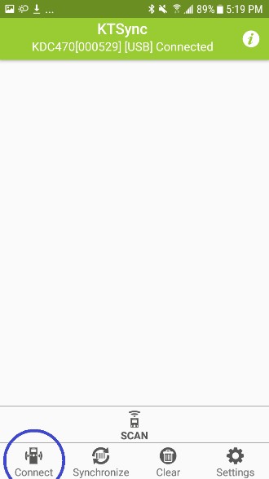 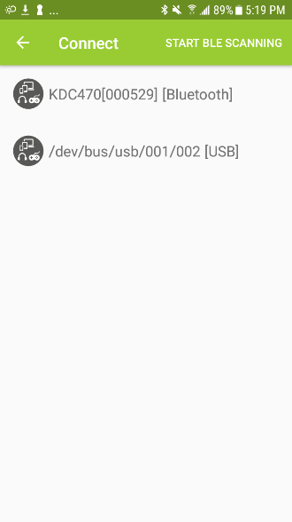 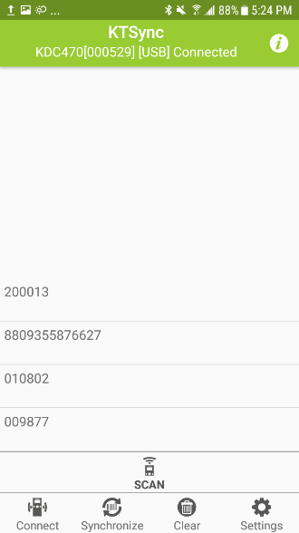

**< Fig. 1 >** **< Fig. 2 >** **< Fig. 3 >**

## Using KTSync Keyboard – Android

Once your KDC is connected to KTSync, you can use your KDC as a keyboard.

1. While KTSync is running in the background, navigate to Settings > Language & Input > Virtual Keyboard > Manage keyboards
2. Tap on “KTSync Keyboard” to enable it.
3. Change “KTSync Keyboard” to the default keyboard. (Fig. 4)

To switch back to the previous keyboard, simply change the default keyboard again. Or, when a text field is selected swipe down from the top of the screen to bring up the notification panel. Select ‘choose input method’ and you can select the default keyboard from here. (Fig. 5)

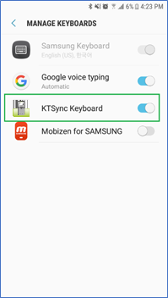 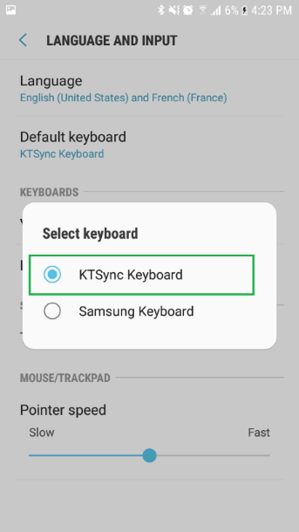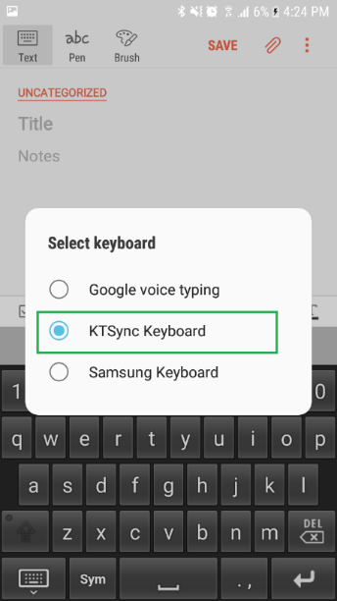

**< Fig. 4 > < Fig. 5 >**

## Using KTSync Keyboard – iOS

Once your KDC is connected to KTSync, you can use your KDC as a keyboard.

1. Navigate to the iPhone/iPad/iPod Settings > General > Keyboard > Keyboards > Add New Keyboard... > Select the KTSync keyboard to be added. (Fig. 6)
2. Select the KTSync Keyboard and toggle the switch to Allow Full Access. (Fig. 7)

 

**< Fig. 6 > < Fig. 7 >**

1. Open the application you want to scan into and tap on the screen, so the on-screen keyboard appears.
2. Press and hold the globe icon located to the left of the spacebar.
3. Select the KTSync Keyboard and begin scanning. (Fig. 8)

  
**< Fig. 8 >**

Note: The KDC must be connected to KTSync & the KTSync keyboard must be selected for this to work.

## Using “KDCUHF” Application – Android/iOS

Download the “KDCUHF” application from the Google Play Store or from the Apple App Store and install it. After pairing your device in section 2, you can do the following:

1. Start KDCUHF you just installed then KDCUHF is trying to connect with KDC among paired KDC list.
2. If you want to connect to the specific KDC, please use the menu “Connect” from KDCUHF.

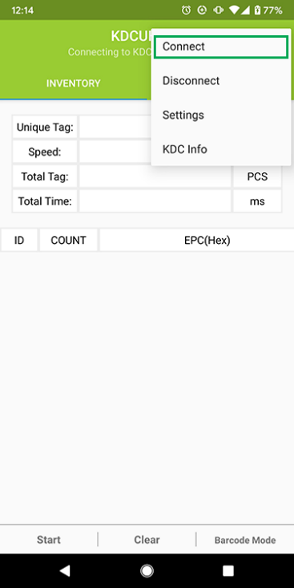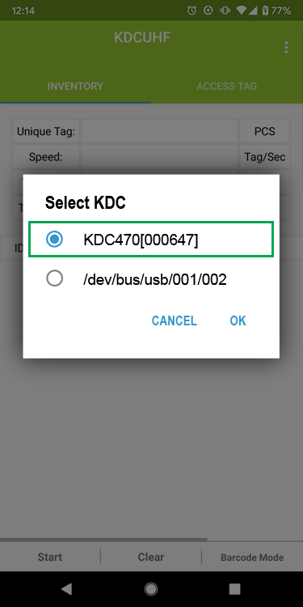

1. Select “INVENTORY” and approach your UHF tags to read.
2. Then tap on “Start” button or press the physical SCAN button on the KDC.
3. You might hear multiple fast beeps while reading depending on the number of UHF tags nearby and depending on UHF configuration.
4. You can clear the current information with “Clear” button to re-read.
5. To change the read mode, select the Barcode Mode button.

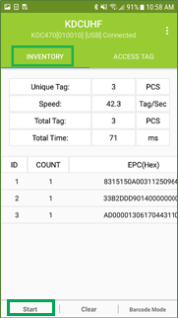

|  |  |
| --- | --- |
| Unique Tag | Number of unique tags read |
| Speed | Average speed to read tags, in pcs/s (Total Tag / Total Time) |
| Total Tag | Total number of tags read |
| Total Time | Total time it takes to read, in ms |
| ID | ID for unique tags |
| COUNT | Number of reads for each unique tag |
| EPC | EPC data of tag read |
| PC | PC data of tag read |

## Using other Developed Applications with free SDK – Android/iOS

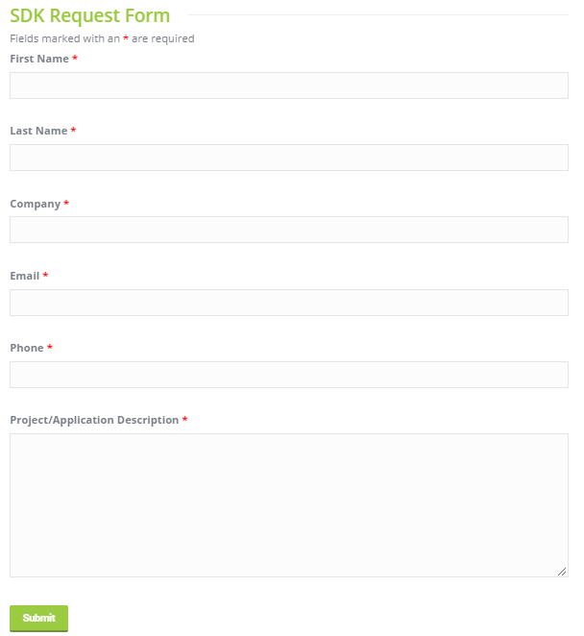A Software Development Kit (SDK) for Android and iOS is available to all KOAMTAC customers to ensure smooth development of applications that work seamlessly with a KDC scanner. It’s easy to request the SDK from the KOAMTAC website:

1. On any web browser, open www.koamtac.com
2. Navigate to SUPPORT > Downloads > [SDK](https://www.koamtac.com/support/downloads/sdk/)
3. Complete the form and submit it.

After submission, a KOAMTAC representative will reach out regarding next steps for completing the SDK Agreement.

The SDK package will have libraries, documents, a sample application, and its source code.

# Product Specifications

## 1.0W UHF Reader

|  |  |  |
| --- | --- | --- |
| Physical | Design | Pistol Grip UHF Reader |
| Weight (w/o KDC) | 14.99 oz (425 g) |
| RFID Details | Supported Standards | EPC Class1 Gen2, EPC Gen2 V2 |
| Nominal Read Range | 20’+ (6m+)  dependent on tag type and operating environment |
| Frequency | US, EU, JP, KR |
| Output Power Range | +0 to +33dBm |
| Read Rate | 200 tags per second |
| Tag Storage | 409,600 RFID tags  (in case of 12 bytes of EPC Data) |

## 0.5W UHF Reader

|  |  |  |
| --- | --- | --- |
| Physical | Design | UHF Reader |
| Weight (w/o KDC) | 1.85 oz (53 g) |
| RFID Details | Supported Standards | EPC Class1 Gen2, EPC Gen2 V2 |
| Nominal Read Range | 5’+ (1.5m+)  dependent on tag type and operating environment |
| Frequency | US, EU, JP, KR |
| Output Power Range | +13 to +27dBm (Japan +18 to +23dBm) |
| Read Rate | 100 tags per second |
| Tag Storage | 409,600 RFID tags  (in case of 12 bytes of EPC Data) |